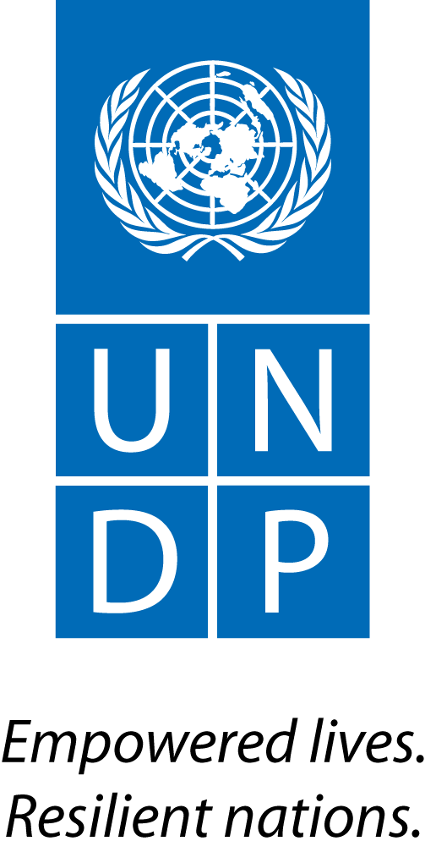 | United Nations Development Programme | MEETING MINUTES  Drafted by: Joseph Conteh (Youth Intern)  Date Submitted: ^{21st} March, 2016
1. Title: Ebola Response-Livelihoods, Government of Japan Project Board Meeting
2. Objective: (i) To provide project implementation updates (specifically on the livelihood component) and to give an overview of the 2016 AWP (ii) To discuss and seek approval from the board for the 2016 AWP
Brief Remarks
The Team Leader, Inclusive Growth Cluster - welcomed members of the board and summarized the purpose of the meeting, with discussions centrally focused on the livelihood component of the project. He further gave a short overview of the project, being a continuation of planned project activities from the previous year.
3.0 PROJECT UPDATE AS AT JANUARY 2016
The Deputy Team Leader, Inclusive Growth Cluster - presented project implementation updates, highlighting the following key notes under outcome 2 of the project document:

ACTION AID
- Stakeholders and community engagement meetings held in Magbema, Masungbala,Bramaia and Tonko Limba chiefdoms.
- A rapid baseline and market analysis of Kambia District completed and report shared with UNDP. The findings have been used as a basis of beneficiary selection and as a guide to project implementation..
- Food and non-food support distributed to 90 Ebola survivors
- They provided business training and start-ups for 80 Ebola affected women.
- They have identified 7 farming groups of 10 members each for cash-for farming to start soon.
- 90 survivors, widows and orphans have been supported with food items.
- They have identified 70 rice and vegetable growers targeted for Agric input support and extensive farming.
- They have also identified70 livestock breeders targeted for rearing goats, sheep and poultry.

MoPADA-SL
- A rapid baseline and market analysis for Kailahun District completed and report shared with UNDP.
- The findings have been the basis of beneficiary selection and as a guide to project implementation.
- They have completed district stakeholders and community engagement meetings, but continue close follow up meetings with communities where implementation is ongoing.
- 100 farmers consisting of 15 groups received farm tools and vegetable gardening tools for their farming activities
- 200 beneficiaries identified, trained and supported with start-ups and operate a Village Savings and Loan scheme.
- 40 beneficiaries already in business obtained growth skills to grow their businesses
- 100 SME’s trained and linked to financial opportunities.

GRACELAND-SL
- They also completed a rapid baseline and market analysis, findings of which serve as a basis for beneficiary selection and guide to project implementation. Community entry meetings have been completed, with several follow-up meetings
- 94 beneficiaries identified and benefited from the cash-for-work support (mainly road repairs)
- 120 community members engaged in Village Savings and Loan scheme and agribusiness initiatives
- 30 youths have obtained skills training in metal works and tailoring (through CaWEC – a local NGO service provider).
- Psychosocial counselling sessions conducted in all three chiefdoms (Samu, Gbinle Dixing and Mambolo), benefitting a total 120 persons.

WORLD VISION
- A Project Coordinator has been hired and deployed in Pendembu to cover all three chiefdoms (Dea, Upper Bambara and Malema) in Kailahun District
- Their procurement processes has been completed and project implementation is in progress.
- Community engagement meetings held with 106 beneficiaries in attendance
- A Memorandum of Understanding (MOU) has been signed with financial service providers (Airtel), for cash transfers to support 100 beneficiaries.
- Conducted and completed a rapid baseline and market analysis, to inform beneficiary selection and guide project implementation.
- Verification of project beneficiaries ongoing, for both cash transfers and Village Savings and Loan Scheme.
- Village Savings and Loan scheme training still pending and plans are underway.
- World Vision is partnering with World Hope International for the construction of Greenhouses.

In his concluding statement, the Deputy Team leader indicated that the project actually had a slow start, as a result of multiple reasons, ranging from the change of context in the Ebola Response, lengthy bureaucracies at UNDP and delays in fund transfer to Implementing Partners’ accounts, just to name a few. UNDP teams conducted monitoring visits to both Kambia and Kailahun in the months of November 2015, January and February 2016; and intends to make a detailed visit in the next coming weeks, in order to verify implementation updates provided by the implementing partners.

3.1 COMMENTS AND QUESTIONS
- The National Youth Commissioner who co-chaired the project board meeting was concerned on the level of visibility given to the project in the localities, where the projects are implemented. The Commissioner also suggested having the District Youth Councils involved in the projects, in order to build synergies and to harmonise on-going youth activities in the districts.
- It was agreed that, joint monitoring visits be undertaken, involving the Youth Commission. In the area of the cash-for work, for future engagements, he suggested that it should be narrowed down to agribusiness initiatives, as it offers a more sustainable economic growth for individuals and communities.
- Lastly, the 30 youths trained in Kambia to be followed closely, in order to ensure job placements for them..
In response to the Youth Commissioner’s concerns, it was communicated that, UNDP was involved in all pre-engagement and stakeholders meetings in both Kambia and Kailahun – informing communities that the projects are being supported with funds from the people of Japan, administered by UNDP.
Quite recently, specifications for sign posts were shared with all Implementing Partners, with clear details of the people of Japan logo, UNDP logo etc. Communities and beneficiaries are well aware.
Concerns were also raised as to why the Security Sector part of the Japanese project, was not implemented in Kailahun District. This was to be looked into, if a long term GOJ project is to be considered.

3.2 OVERVIEW OF AWP 2016
An overview of the above was given by the Team Leader - Inclusive Growth and emphasized that the activities were a continuation of those already on-going, with grants awarded to implementing partners The board was quite clear with the AWP, and only flagged the following:
- UNDP to follow up with the Implementing Partners and ensure that beneficiaries utilized start-ups for the required purposes and also ensure placements for those who undergo skills training.
- The management cost as indicated in the AWP, seemed a bit higher.
The Board Members however endorsed the 2016 AWP and was signed by the Commissioner of The National Youth Commission – Co Chair of the project board.

3.6 Follow-up
Actions to be taken |  | By Whom | Expected Completion Date
- Action Aid and Graceland-SL are to review their baseline report and make the required adjustments, the re-submit to UNDP. |  | Action Aid and Graceland - SL | ASAP
- UNDP to give prior notice to the board on the next project-monitoring visit, in order to give them a chance to participate. |  | GOP Project Manager | 30th March 2016
- To circulate the minutes of this meeting. |  | GOJ Project Manager | 22nd March 2016

